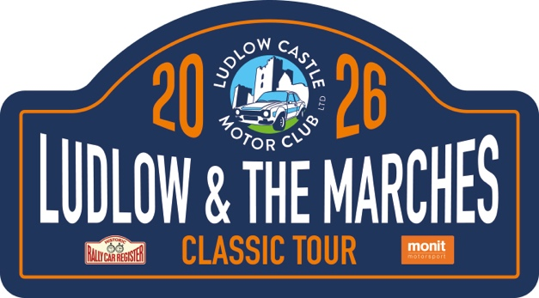
Ludlow Castle Motor Club

Ludlow & The Marches Classic Tour 2026

Supplementary Regulations

Organisation
- Ludlow Castle Motor Club will organise the Ludlow and Marches Classic Tour, a Touring Assembly on 11th of October 2026.
- The event will be held under a Certificate of Exemption issued by Motor Sport UK, these Regulations and any other written instructions given by the organisers.

Eligibility
- The event is open to three and four wheeled cars manufactured up to 2006. Other cars of interest may be accepted at the organisers’ discretion.
- The event is open to members of the organising club, members of the HRCR and members of WAMC affiliated clubs. Members of the public are also invited to participate. The event is included in the HRCR Scenic Tour Series 2026.
- Drivers must hold a valid driving licence, a specific competition licence is not required.
- All cars must hold a V5C Registration Document, be taxed for use on the public highway, insured and carry a valid MOT certificate, if applicable.

Entries
- Entries are open from September 1st 2026 and close on October 4th 2026.
- The entry fee of £125 will cover a “tulip” style road book, tour plate to be affixed to the front of the vehicle and a participant’s award. Also included are bacon sandwiches together with tea and coffee for drivers and passengers at the start, 2 comfort breaks, and a meal at the finish.
- Additional passengers will be accepted at an additional cost of £45 per person.
- Payment for entries can be made directly by BACS to Ludlow Castle Motor Club, the details are: Sort code 53-50-41 and the Account number is 10573739
- Entry Form can be accessed here on September 1st: https://www.rallies.info/webentry/2026/ludlowtour
- The maximum number of cars will be 70 with a minimum of 50, should the minimum not be reached the organisers reserve the right to cancel the event and return any received entries.
- Entry fees will be refunded up to the closing date for entries, less a £20 administration fee. Refunds after this date will be subject to a decision by the Clerk of the Course.
- Should the event be cancelled, then entrants will be given the option to transfer their entry to next year or to receive a refund.
- Entry payment is to Ludlow Castle Motor Club by Bacs only
- Any entrant who driving standards deemed not to be within the spirit of the event may be denied entry to future events, and asked to leave the event and head for home.
- Entries may be refused without a reason given.

Route
- The event will start from Ludlow Brewery Ludlow https://ludlowbrewery.co.uk/ – where refreshments will be served.
- The Finish will be at Wistanstow Village Hall Map Ref – where a meal will be served.
- The route will be given in an easy to follow “tulip” road book issued at signing on and can be viewed on a printed map.
- The route will be covered on sheets 137 & 138 OS Landranger series and total approximately 105 miles but will not be essential as maps will be provided in the road book.
- Entrants are to be advised that the whilst the majority of the route uses roads that allow two-way traffic some roads are single carriageway and care & courtesy should be taken with regards other road users.
- To confirm entrants have traversed the prescribed routes there will be strategically placed code boards along the route that will need to be recorded together with manned passage controls.
- Whilst this is not a timed event entrants may be requested to wait at manned controls to allow the event to maintain reasonable gaps between cars.
- There are fuel stations along the route, as well as near the start venue.
- The organisers’ mileage will be deemed as correct.

Timetable
- The event timetable will be:
- 1nd August Supplementary Regulations posted
- 1st September Entries open
- 4th October Entries close
- 8th October Final Instructions emailed

11th October
- 7.30 Signing-on & documentation opens
- 8.50 Drivers Briefing
- 9.00 First car starts
- 16.15 First car finishes

Documentation
- It is the entrants’ responsibility to ensure that the vehicle is taxed, road legal and insured for the purpose being used and all drivers are included. The organisers have the right to exclude any vehicle deemed inappropriate or unsafe. Cars may not carry any advertising or door mounted competition numbers unless by previous agreement.
- Entrants will be issued with road books, rally plates and route check cards upon successful completion of documentation.
- Rally plate to be affixed to the car in a forward facing position – cable ties will be provided.

Officials
- Clerk of the Course: David Mills 07966511926
david@dinchope.co.uk

Entries Secretary: Matt Mills
matt@matthewmills.co.uk

Route Master: David Mills

Safeguarding Officer: Simon Williams
- All marshals will be deemed Judges of Fact and will be on duty throughout the day to observe general driving standards.

Finishers
- All finishers that have completed the prescribed route within the specified time will be presented with a commemorative finishers’ award.

Accommodation
- Entrants who are travelling a distance may wish to enjoy the hospitality of Ludlow and the South Shropshire area and a wide range of accommodation can be found by visiting the Tourist Information Centre web site. https://www.visitshropshire.co.uk/sleep/

Protests
- There won’t be any!

The organisers hope that you have a good days motoring in this beautiful area Ludlow and the Marches.

If you would like to join Ludlow Castle Motor Club please contact our membership secretary Emma Clarke at members@ludlowcastlemotorclub.co.uk

